

Attendance Updation Using Group Image

(Embedded System)

(CS-313)

Submitted By: -

Shyam Sundar Kumawat

B15CS038

Satyaveer Nayak

B15CS032

S S Sri Karan

B15CS029

N. Vishnuvardhan Reddy

B15CS036

Title: - Attendance Updation Using Group Image.

Description: - This application help us to update class attendane from a group image.The input to the system will be a group image,The system detects the faces of the students and updates their attendance automatically.

Student those who wants to attend a particular course, have to register themselves with all proper details and one personal photo. Details must be given by the student are Name, Roll no, Email, Password, Course-Name, Course-Id and Sem.

Teachers who are assigned to teach a particular course, have to register themselves in the portal with their proper details. Details must be given by the teacher are Name, Email,Mobile No., Password, Course-Name, Course-Id and Sem.

The access to update attendance will be given to teacher only. By Logging into the portal, teacher will have to give the date and couse id.Then have to upload a group image. System will process this group image and by detecting faces, attendance will get update automatically.

Students, By logging with Email id and password, they can see their profile and their attendace.

Tool: - Android Studio, Firebase.

Languages: - Java, Xml, Mysql.

Platform: - Android.

Working Process:-

1)

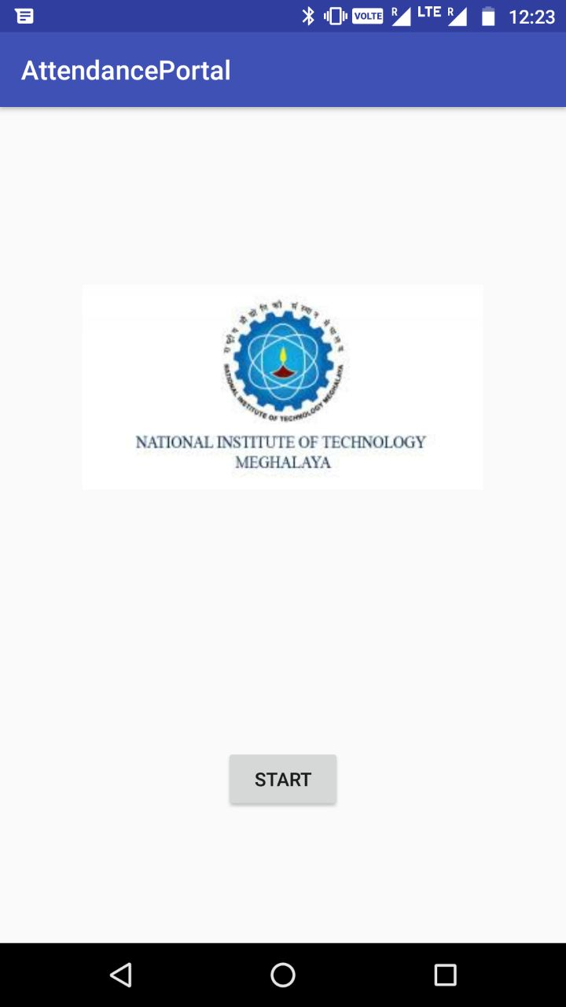

* This is the very first page of the application, As we can see from the image above, there is a button called **START** which takes us to the next page of the application.
* Logo of the **NITM** and the name of the application is also shown in the page.

**2)**

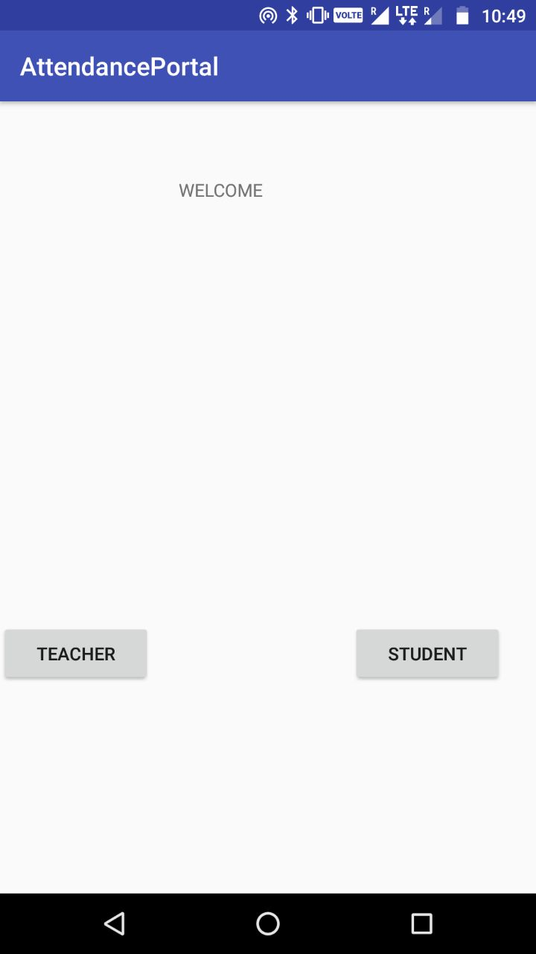

* The second page of the application is the welcome page, where we have two buttons namely 1) **TEACHER 2) STUDENT**
* 1) TEACHER**:-** Clicking on this button will take you to login page where you should login to continue or you can register yourself to get your login credentials provided your details match with the
* 2) STUDENT**:-** Clicking on this button will take you to login page where you should login to continue or you can register yourself to get your login credentials provided your details match with the documents that you have submitted at the time of you admission.

**3) REGISTRATION PROCESS:**

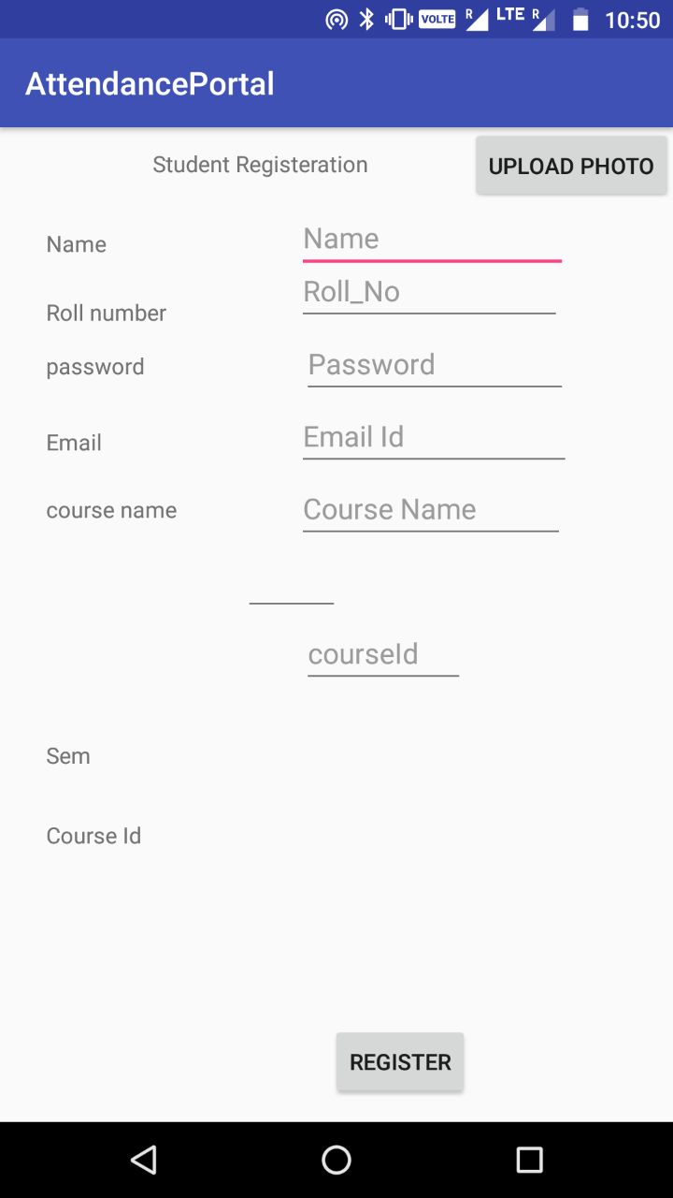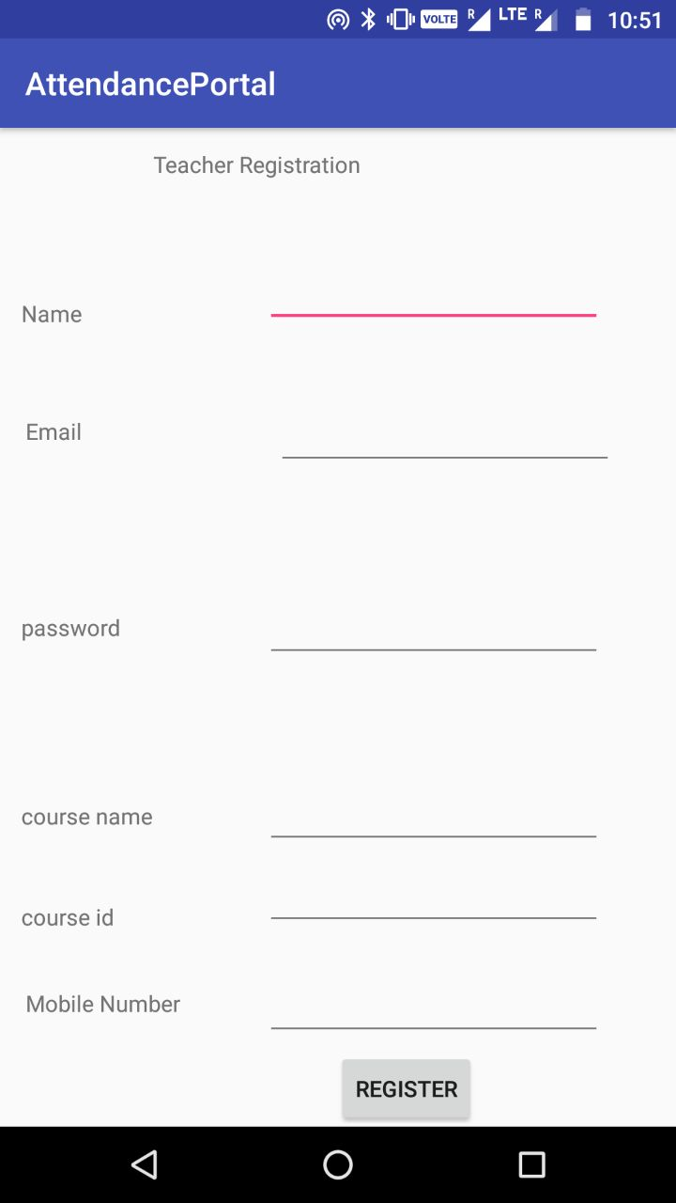

* To make use of this application from student’s prospective, he/she has to register themselves first by entering the details as asked above in the image,A passport sized photograph of the student should be uploaded.
* After you complete your registration each and every detail of every student will be verified with the documents that you have submitted at the time of your admission,A conformtion mail will be sent to your registered E-mail about the status of your registration.

4)LOGIN PAGE:

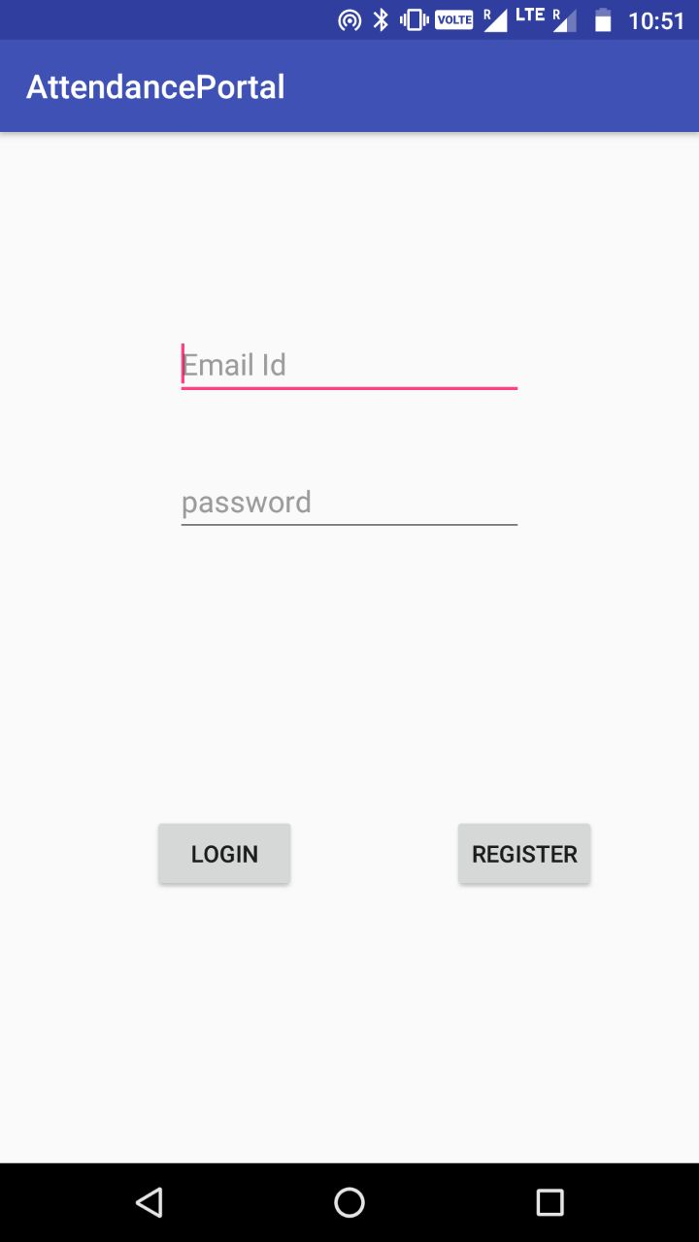

* This page looks similar to that we see daily in some of the real time applications.
* Here you have two options 1) LOGIN 2) REGISTER
* If you are new to this application you have to register youself where you have to fill up a form.
* Old users can login by entering his/her login credentials.
* Students can view their attendence once they login.
* Teachers have the rights to upload the group image, where the system recognizes the faces and uploads the attendance.

**Algorithm : -**

1). Take input data from each frame.

2). Input data is stored in Firebase(It is a online database which accepts

data and stores in tree-format). Where the Email address is node.

This node will contents all information as its child node.

3).Whenever teacher or student wants to login. They have to fill their

Email address and password. It will search using Email address.

The search operation is done in O(n) time.

4). If teacher/student logged in. It will display their profile and provides

the operations that they have privileged.

5). Face detection is done by DIGITAL IMAGE PROCESSING

technique where it takes image as input and stores in RGB

binary-image format.Then it perfoms face detection operation over it.

**Code for FaceDetection:-**

import face_recognition

import cv2

image = face_recognition.load_image_file("msd.jpg",mode="RGB")

face_locations = face_recognition.face_locations(image)

face_landmarks_list = face_recognition.face_landmarks(image)

unknown_image = face_recognition.load_image_file("msdunknown.jpg",mode="RGB")

biden_encoding = face_recognition.face_encodings(image)[0]

unknown_encoding = face_recognition.face_encodings(unknown_image)[0]

results = face_recognition.compare_faces([biden_encoding], unknown_encoding)

print(results[0])

if results[0]==True :

print("This is Capitan cool")

else:

print("not detected")

6). Whenever a face is detected. It will take their email id and will

update their attendance with date.